Invention Disclosure Form

Industrial Designs
Chandigarh University IPR Cell
INSTRUCTIONS:
1. Go to File 🡪 Download 🡪 Microsoft Word (.docx)
2. Download the IDF in your local storage
3. Explain your invention comprehensively in the form.
4. Save your IDF file with the name of the Title of your invention. eg: "A Smart Electric Kettle"
5. Upload the duly filled IDF below.
Email To: patents@cumail.in

INVENTOR DETAIL(s):

NAME: | MOHD SHAN
GENDER: | MALE
EMAIL: | THEMOHDSHAN@GMAIL.COM
MOBILE NO: | 9084296657
DEPARTMENT: | BE-CSE
DESIGNATION: | STUDENT
SCANNED HAND SIGNATURE: | 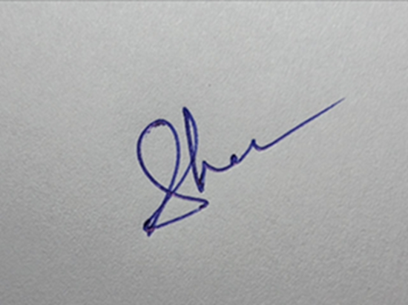

OTHER INVENTOR DETAIL(s):

NAME:
GENDER:
EMAIL:
MOBILE NO:
DEPARTMENT:
DESIGNATION:
SCANNED HAND SIGNATURE:

Title of the Design
Magnetic Pendrive Bottle

Choose the Class of the Design

LIST OF CLASSES (Third Schedule))
Class 1 FOODSTUFFS  Class 2 ARTICLES OF CLOTHING AMD HABERDASHERY  Class 3 TRAVEL GOODS. CASES. PARASOLS AND PERSONAL BELONGINGS, NOT ELSEWHERE SPECIFIED  Class 4 BRUSH WARE  Class 5 TEXTILE PIECE GOODS, ARTIFICIAL AND NATURAL SHEET MATERIAL  Class 6 FURNISHING  Class 7 HOUSEHOLD GOODS, NOT ELSEWHERE SPECIFIED  Class 8 TOOLS & HARDWARE  Class 9 PACKAGES AND CONTAINERS FOR THE TRANSPORT OR HANDLING OF GOODS  Class 10 CLOCKS AND WATCHES AND OTHER MEASURING INSTRUMENTS, CHECKING AND SIGNALLING INSTRUMENTS  Class 11 ARTICLES OF ADORNMENT  Class 12 MEANS OF TRANSPORT OR HOISTING  Class 13 EQUIPMENT FOR PRODUCTION. DISTRIBUTION OR TRANSFORMATION OF ELECTRICITY  Class 14 RECORDING, COMMUNICATION OR INFORMATION RETRIEVAL EQUIPMENT  Class 15 MACHINES, NOT ELSEWHERE SPECIFIED  Class 16 PHOTOGRAPHIC CINEMATOGRAPHIC AND OPTICAL APPARATUS |  | Class 17 MUSICAL INSTRUMENTS  Class 18 PRINTING AND OFFICE MACHINERY  Class 19 STATIONERY AND OFFICE EQUIPMENT, ARTISTS' AND TEACHING MATERIALS  Class 20 SALES AND ADVERTISING EQUIPMENT. SIGNS  Class 21 GAMES, TOYS. TENTS AND SPORTS GOODS  Class 22 ARMS, PYROTECHNIC ARTICLES. ARTICLES FOR HUNTING. FISHING AND PEST KILLING  Class 23 FLUID DISTRIBUTION EQUIPMENTS, SANITARY.HEATING. VENTILATION AND AIR-CONDITIONING EQUIPMENT.SOLID FUEL  Class 24 MEDICAL AND LABORATORY EQUIPMENTS  Class 25 BUILDING UNITS AND CONSTRUCTION ELEMENTS  Class 26 LIGHTING APPARATUS  Class 27 TOBACCO AND SMOKERS' SUPPLIERS  Class 28 PHARMACEUTICAL AND COSMETIC PRODUCTS, TOILET AND APPARATUS  Class 29 DEVICES AND EQUIPMENT AGAINST FIRE HAZARDS. FOR ACCIDENT PREVENTION AND FOR RESCUE  Class 30 ARTICLES FOR THE CARE AND HANDLING OF ANIMALS  Class 31 MACHINES AND APPLIANCES FOR PREPARING FOOD OR DRINK NOT ELSEWHERE SPECIFIED  Class 99 MISCELLANEOUS

Description of the Design

This section captures a detailed explanation of the design, its purpose, and uniqueness.
Guidelines: Clearly describe the design’s features, functions, and how it is novel compared to existing designs.
Be sure to use as much space as needed, and be as detailed as you can in this section, as anything that is not covered here will not be protected under the patent we may obtain.
Class of Design | 9 AND 14 MAY BE

Brief Description of the Design (Max. 500 words):
This design is for a smart water bottle that has a hidden magnetic slot to hold a USB pendrive. The pendrive fits neatly on the side of the bottle and stays attached using a magnet. It can be easily removed whenever needed and placed back after use.
The pendrive does not disturb the bottle’s drinking function. The design is made in such a way that the pendrive stays safe and secure even when the bottle is carried around. This design is helpful for people who carry important files, presentations, or documents in digital form—like students, office workers, or business professionals.

Purpose and Aesthetic Aspects of the Design: | The purpose of this design is to provide a convenient way for people to carry both water and a pendrive in a single stylish product. It saves space and keeps the pendrive safe and easy to access without digging into a bag or pocket.  From an aesthetic point of view, the design looks modern and sleek. The pendrive is hidden in the body of the bottle, giving it a clean and minimalistic look. The magnetic feature adds a cool and high-tech touch to the bottle’s appearance.
Novelty and Uniqueness of the Design: | This design is unique because it combines two everyday items—a water bottle and a USB pendrive—into one smart, space-saving product.  While there are many water bottles and pendrives in the market separately, this is the first of its kind that allows you to carry and access a USB drive directly from your water bottle.  The magnetic slot is designed specially to hold the pendrive safely, which makes it a new, innovative, and multi-functional product.
Existing Similar Designs (if any) and How This One is Different: | NO

Declaration and Signature
This section secures formal confirmation of the provided information's accuracy. Guidelines: Read carefully before signing. Ensure that all details provided are correct to avoid future discrepancies.
“I/We declare that the information provided above is true and correct to the best of my/our knowledge. I/We understand that any misrepresentation may affect the protection of the design.”

E-Signature of Inventor(s): | SHAN

